  - ITEM Metadata: Define if/how you will use each field below.
Dublin Core Field | Description | Field definition for your project
Title | Name the resource
Subject | Topic of the resource. You can use the Library of Congress subject headings or create your own.
Description | Use 2-3 phrases or sentences to describe item, especially visual material
Creator | Author, artist, interviewer/interviewee, etc.
Source | Archive, book, or other source of the item
Publisher | Entity responsible for making the resource available
Date | Date of item's creation or event
Contributor | Donor or team member who adds item
Rights | What rights and restrictions pertain to the item? Can someone download it, reuse it, view the physical item, etc.?
Relation | A related resource in Omeka site or external
Format | Physical format: dimensions or original digital file type (mp3, wav, etc.)
Language
Type | Optional: Choose one of the 14 Omeka Item Types (list is on the next page)
Identifier | Unique name
Coverage | Location & time period/date

  - COLLECTION Metadata: Determine which fields to use if you decided to add your items to Collections.
Dublin Core Field | Description | Field definition for your project
Title | Name the resource
Subject | Optional: Topic of the resource. You can use the Library of Congress subject headings or create your own.
Description | Optional
Creator | Optional
Source | Optional: Archive, book, or other source of items in the Collection.
Publisher | Optional: Entity responsible for making the resource available
Date | Optional: Date (range) of items in the collection.
Contributor | Optional: Donor or team member who adds item
Rights | Optional: What rights and restrictions pertain to the item? Can someone download it, reuse it, view the physical item, etc.?
Relation | Optional: A related resource in Omeka site or external
Format | Leave blank unless all items are the same format (text documents, photographs, etc.)
Language
Type | Leave blank unless all items are the same
Identifier | Unique name
Coverage | Location & time period/date(s)

  - Potential Collections

  - TAGS Brainstorming:

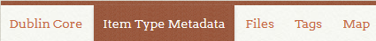
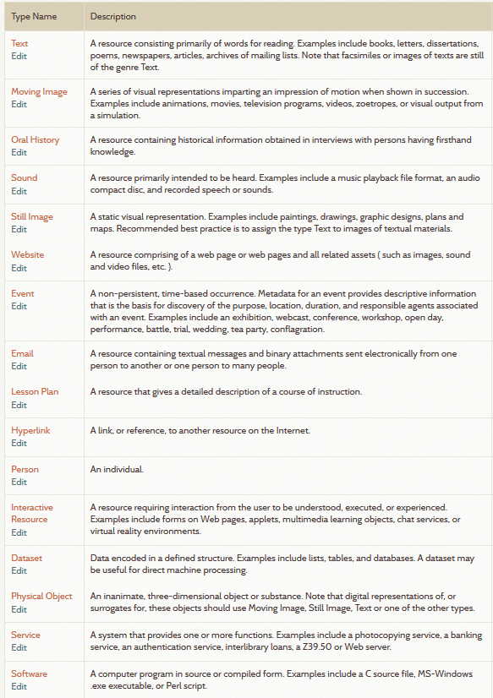
Other Examples: Musical Score
(You will need to add this Item Type if you want to use it)

  - Team Project Plan:
Site Title:

Description:

Team members and roles:

Materials to include:

Audience:

Purpose:
  - Appearance: See omeka.net/showcase for ideas.
Colors (Background, Text, Buttons):

Header (Image, Icon, Logo, etc.):

What should the home page look like? (describe or sketch below)

  - Potential Exhibit Topics

Sketch some ideas for exhibits below:

